Welcome to an evening of St Lapping

Please familiarize yourself with these St Lap Rules to ensure an enjoyable and successful experience. Drivers are expected to conduct themselves in a mature and responsible manner taking into account the various abilities of the other drivers. Drivers shall respect the directions and decisions of the officials at all times. The St Lawrence Automobile Club reserves the right to deny participation at any time.
Familiarizing Yourself with the Track
Please visit the following links for an in-car look at the track layouts:
Fabi; https://www.youtube.com/watch?v=AOQEttMukdc June 25th, Sept 24th
(horrible apexes but provides a simple look at the layout)
Long track: https://www.youtube.com/watch?v=YSBY2Jzacbs July 16th, Aug 27th
(nice track map includes)
Pro track: https://www.youtube.com/watch?v=6nABNrV-NoM July 30th
Lapping Night: What to Expect
Personal Checklist
Helmet -2010 DOT , FIA, and newer | Face mask
Closed shoes, long pants | YOUR PASS
Air pig if needed, torque wrench, extra gas and fluids | YOUR COMPLETED SELF TECH FORM
Rain gear, sun gear, snacks ,drinks

Itinerary
5:00 Registration Opens | 5:15am Mandatory Drivers Meeting
5:30 On track sessions begin with 15 minutes session 5 minutes to transition each group - turn out will determine number of stints- 45 minutes is the minimum with a full turn out - likely closer to an hour as we get fine tuned
Race Group On track Sessions 1,4, 7 | 15 minutes with 5 minute turn around
Novice Group Run Sessions 2, 5, 8 | 15 minutes with 5 minute turn around
Experienced Group On track Sessions 3, 6, 9 | 15 minutes with 5 minute turn around

Entering the Park
Please follow the access road to Fabi.
You will be met by a club official who will ask you for a completed Technical Checklist which can be found in the Appendix at the end of this document.
You will also be asked to fill out a Waiver of Liability which will be provided to you at Registration.
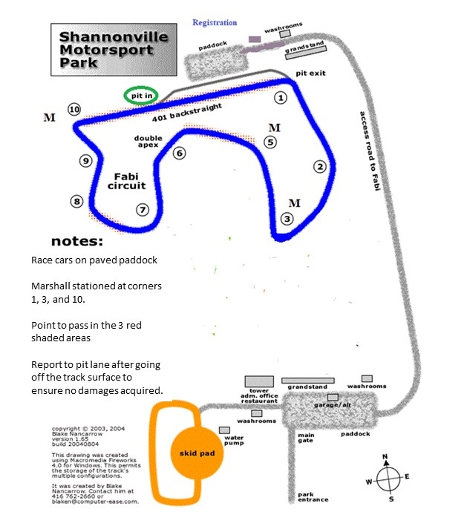

Lapping instruction will be provided at the mandatory Driver’s Meeting. They can also be found on the above map under notes.
Appendix

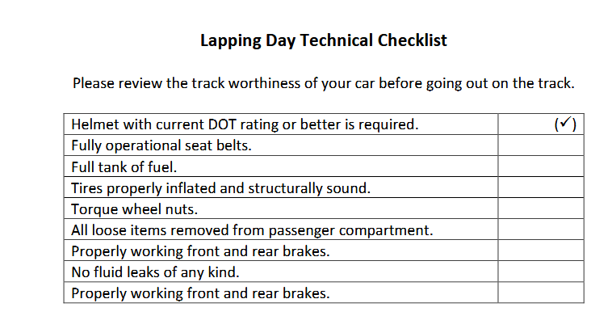

Meaning of the flags

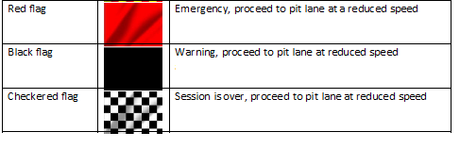

If something does not feel right please proceed to the paddock and check with an official.

